 | 

“In-Situ Mobile Application for the Triage of Pedestrians in Vehicle Collision”
(SENTINEL)
RST 358_13_23
Progress Review Report 1

Written by | Dr Christophe Bastien | Date: 29/04/2025
Version: | 2.0

Executive Summary
The project SENTINEL, funded by the Road Safety Trust, aims to improve the triage of pedestrians by the roadside. This 3-year project includes an “Interim progress report 1 Draft Knowledge Sharing Plan” which requires to be delivered by 07/05/2025.
The project is overall going to plan with all the administrative requirements (data sharing agreements and collaboration agreements) between Coventry University, University Hospital Coventry and Warwickshire NHS Trust (UHCW), West Midlands Ambulance Service (WMAS), and The Air Ambulance Service (TAAS) signed off.
There is a small delay in the approval with the Integrated Research Application System (IRAS) (343910), related to the recruitment and consent of pedestrian victims by the roadside. A formal review was conducted on 01/04/2025, which was positively received. The review led to necessary modifications regarding the study protocol and improved clarity for the patients’ consent and participant information sheets (PIS). The development of the study protocol was more challenging than expected, as the NHS processes between UHCW, WMAS and TAAS were at the onset not seamlessly integrated. These changes have been reviewed by all study members and will be submitted to IRAS by 08/05/2025 for final review.
During the period from 04/11/2024 (beginning of SENTINEL) and 07/05/2025, three work packages (WP) were involved: a) WP1: Human Finite Element Trauma Model build; b) WP3: Accident Evidence and EPR merging, and c) WP5: Project Management.
WP1 is on-track and has created a survey to engage with scientists, researchers and industry experts. WP1 has secured the collaboration of ARUP, HEXAGON and ALTAIR Engineering, who will each provide 2-year free commercial licences for human computer modelling and AI, worth overall over £300,000. WP1 plans to create toolchain which will allow stakeholders to recreate and develop further SENTINEL upon project completion, via the use of the solver OpenRadioss and specific script provided via GitHub.
WP3 has a slight delay because of the IRAS approval needed modifications. The protocol and data management have been setup so that, should SENTINEL need it, more hospitals could be involved with only minor IRAS amendments. An advanced Aide-Memoire template was created to link the information collection from WP3 to be fed into WP1.
Finally, WP5 has created a dedicated website (https://sentinel-rtc.coventry.ac.uk/ ), presented SENTINEL to various Police Forces, Jaguar Land Rover, the National Highway Traffic Safety Administration (NHTSA) for comments, albeit no Advisory Group Meetings have been yet officially created. Prof Clive Neal-Sturgess and Prof Peter Zioupos, expert consultants to SENTINEL, have been numerously contacted for their advice.

WP1: Human Finite Element Trauma Model build
- Creation of EuroNCAP Adult Impactor Computer Model
Vehicles are assessed against the EuroNCAP head impact test protocol, using an adult pedestrian head impactor weighing 4.5kg with a diameter of 165mm [1]. Areas reachable by an adult head are tested by impacting these zones with this impactor, angled 50deg from the horizontal, at 11.11m/s (25mph).
A technical drawing of this headform is provided in Figure 1 and will be created to calibrate the windscreen stiffness for future computations within SENTINEL.
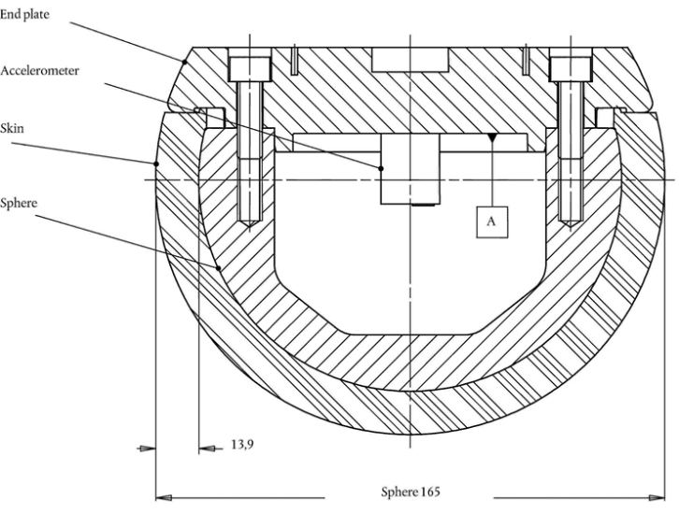
Figure 1: Technical Drawing of a EuroNCAP adult head impactor
Head injury severity is assessed using the head injury criteria (HIC). HIC is computed from the adult head impactor acceleration using the Equation 1.
Equation 1: Had Injury Criteria (HIC) equation
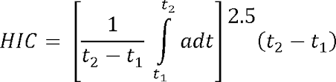
In the model created, using the ARUP software OASYS Primer, as per Figure 2. Total head mass: 4.48kg.

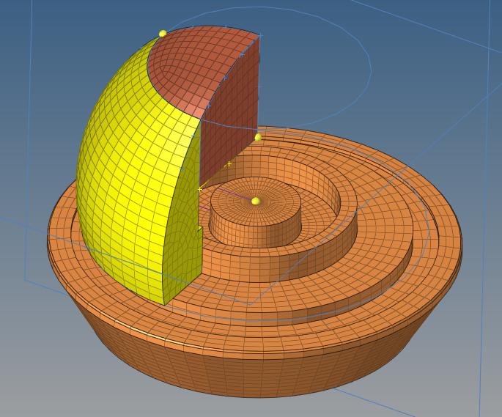
Figure 2: Meshing the bulges from the head model
- Assessment of New EuroNCAP Pedestrian Adult head impactor
The model is tested again a vertical impact speed of 2.7m/s on a rigid plate, as per Figure 3. The acceleration response must lay between 225g and 275g.
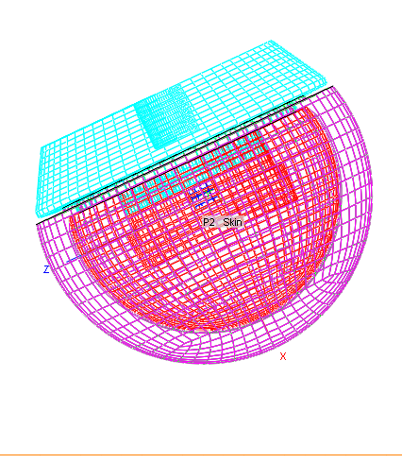 | 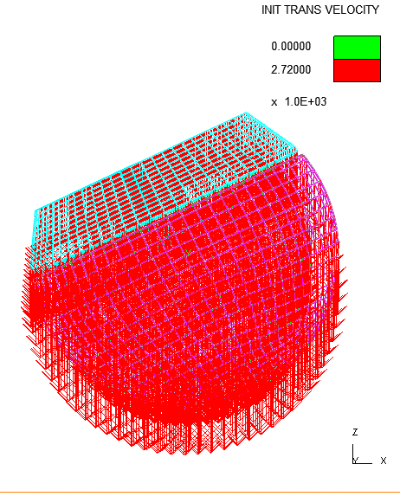
Figure 3: EuroNCAP calibration test. Left: setup; Right: initial velocity
The acceleration response (256g) met the calibration corridors; hence the model is validated and can be used for windscreen calibration.
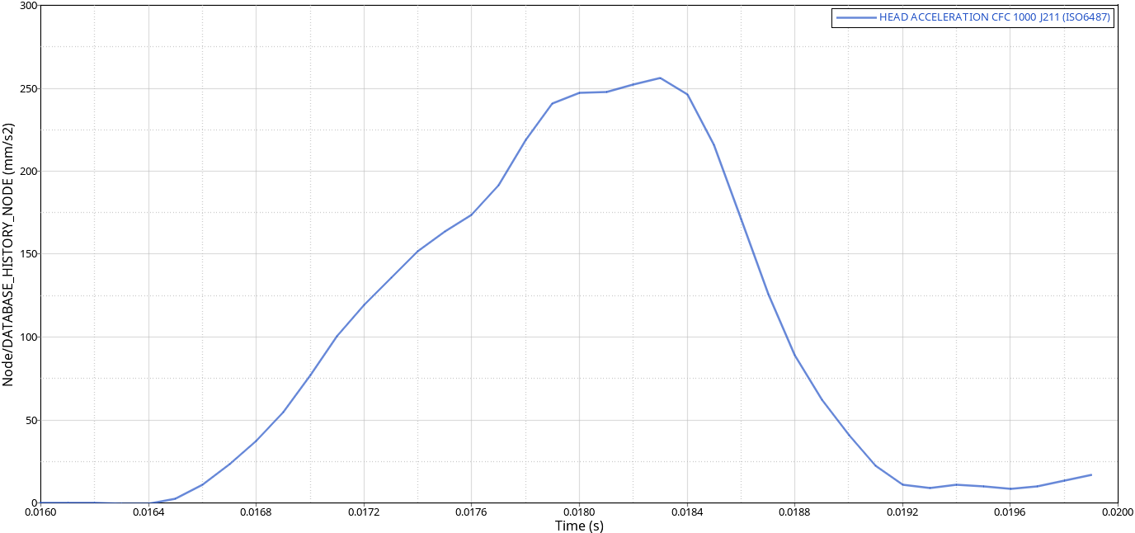
Figure 4: Calibration comparison between BETA version and proposed corrections

- Verification of Human Head Model Response using OpenRadioss
An open source head computer model has been downloaded and tested using the OpenRadioss solver, against the impact test performed by Nahum [2] and Khanuja [3], as per Figure 5. Initial results using OpenRadioss are comparable with LS-Dyna industrial solver (correlation greater than 0.95).
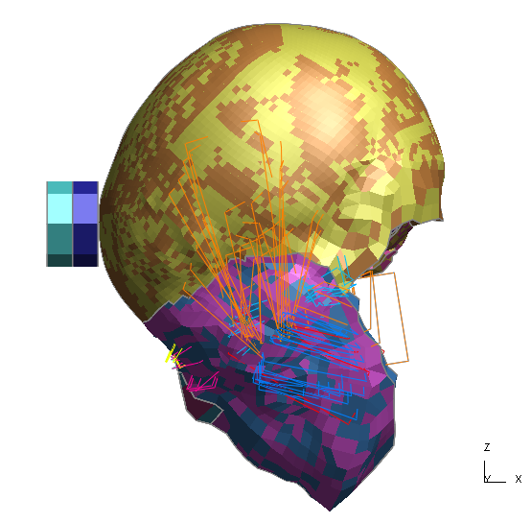
Figure 5: Nahum head impact test.
It can be noted that the simulation results are not in-line with the physical tests highlighting some limitation in the head computer model. These discrepancies could be because the model is complex. Furthermore, this mismatch could be associated to the physical tests, providing only a singular target rather than a mean value bounded by standard deviation corridors, i.e. a tolerance band. Nevertheless, the brain pressure responses follow the experimental trends which justifies the use of this computer model, which is accepted across the industry.
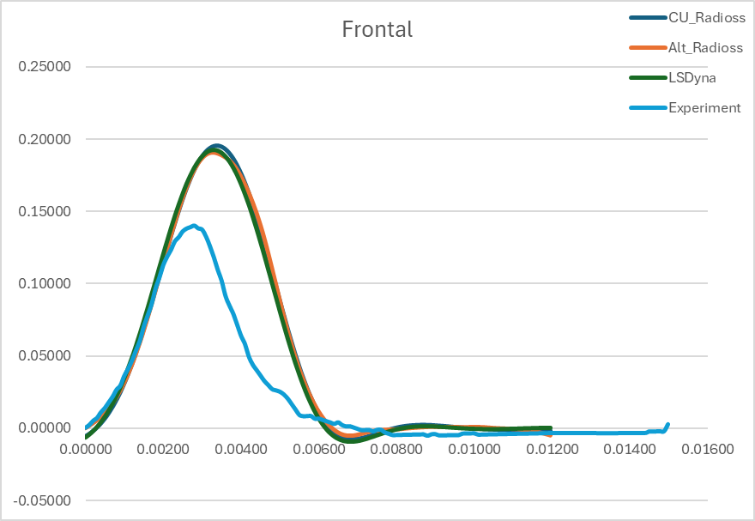 | 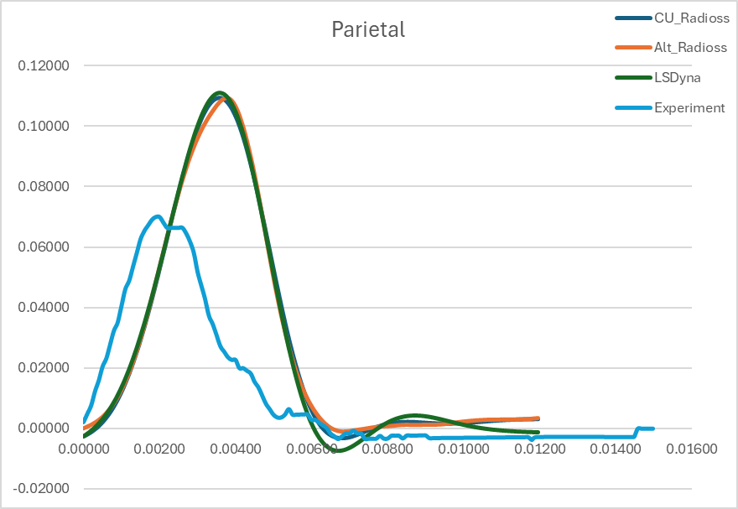
Frontal | Parietal
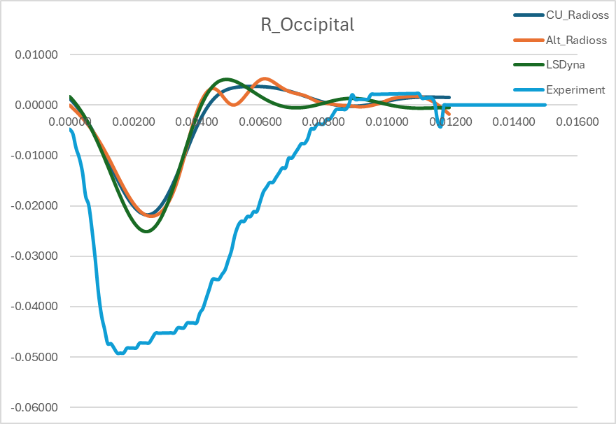 | 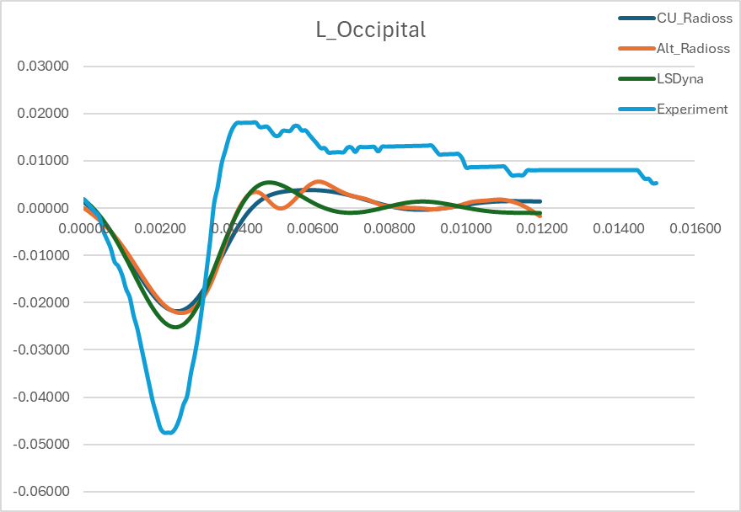
Right Occipital | Left Occipital
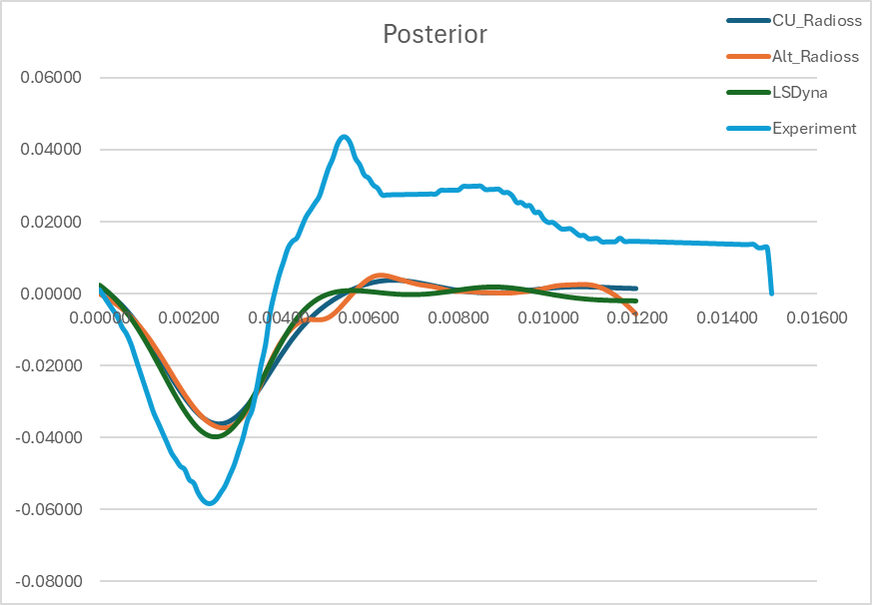
Posterior
Figure 6: Brain Computer Responses vs Experiments
- Creation of a crash test head computer model
To extract injury criteria listed in the survey, SENTINEL needs to create a computer model of a crash test dummy head.
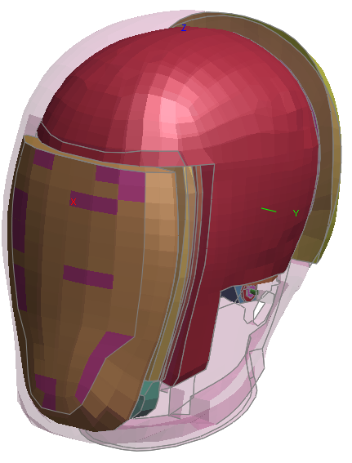 | 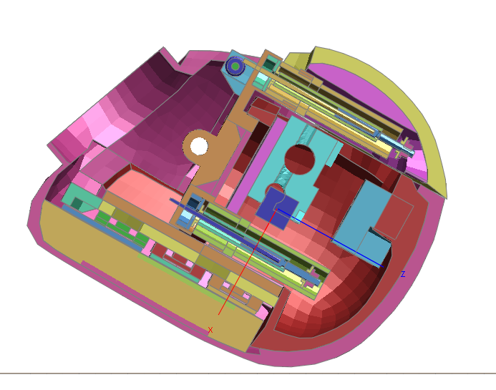
3D view of THOR head model | Cut section of THOR head model
Figure 7: Crash Test dummy head model
A head model was created based on the THOR crash test dummy model. The model was extracted from the main body. The calibration has started
- Creation of parametric windscreen for EuroNCAP rating calibration
Using the adult head model created from section 1.1, a parametric model has been created, as per Figure 8.
This model contains three variables:
- The windscreen angle from horizontal
- The thickness of the said windscreen
- The impact speed of the headform, which is currently setup at 11.11m/s.
This model will be run against a large sample of permutations, so that the right thickness can be computed to replicate an actual windscreen stiffness, for a given windscreen angle.
The model is ready to compute. Results will be available in the next report.

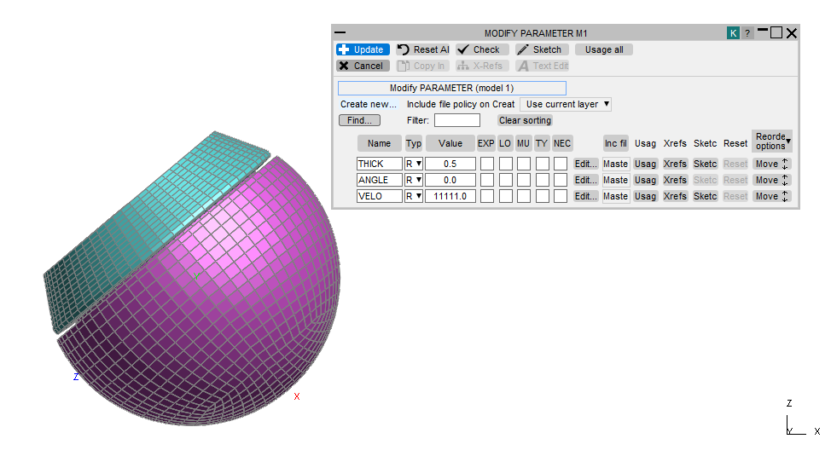
Figure 8: Parametric model to calibrate the windscreen stiffness

- Verification of RAIDS collision speeds
Coventry University has developed an AI tool called PACE-AI. PACE-AI will be used to ensure that the impact speed estimations from RAIDS are reasonable.
Looking at Figure 9, it can be said that RAIDS vehicle impact predictions are close to PACE-AI within 5mph, hence acceptable for SENTINEL.
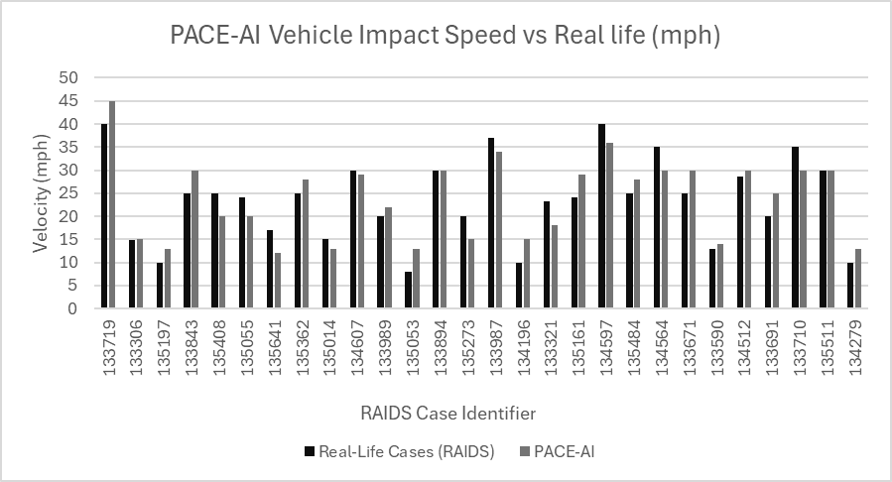
Figure 9: Validation of RAIDS vehicle impact speed predictions

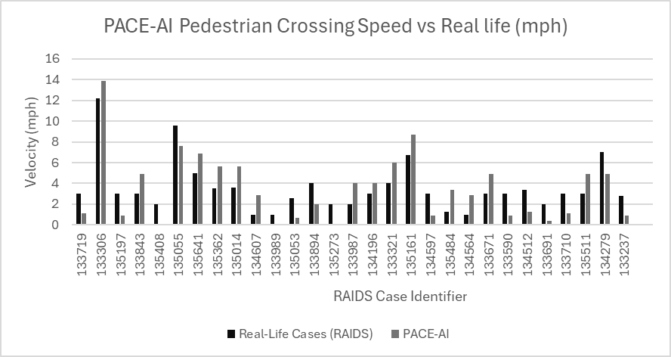
Figure 10: Validation of RAIDS pedestrian crossing speed predictions

Looking at Figure 10, it can be said that RAIDS pedestrian crossing speed predictions are also close to PACE-AI within 2mph, hence acceptable for SENTINEL.
- Extraction of head impact angle and velocities at the time of head contact
Using the RAIDS data and PACE-AI, the head location, impact velocities and impact angles were extracted (Table 1). These will be used to reconstruct the accidents and compare brain injury computer predictions against real-life medical outcomes.
Table 1: Head impact speed and angle at time of contact against the windscreen
Case ID | Time (ms) | Pos_X | Pos_Y | Pos_Z | X_Rot | Y_Rot | Z_Rot | X_Vel | Y_Vel | Z_Vel
133237 | 0.24 | 0.04 | -0.02 | 0.38 | -1.48 | -0.34 | 0.29 | 8.02 | 0.40 | -0.02
133306 | 0.08 | 0.64 | -0.25 | 0.38 | -2.44 | -0.56 | -0.83 | 38.67 | 3.52 | 0.05
133321 | 0.21 | 0.02 | -0.25 | 0.44 | 1.57 | -0.13 | 1.00 | 9.70 | -1.55 | 0.00
133590 | 0.10 | 0.16 | 0.60 | 0.31 | -1.81 | -0.28 | 0.22 | 23.53 | 0.86 | 0.03
133671 | 0.09 | 0.17 | 0.47 | 0.30 | 2.48 | 0.49 | 1.85 | 30.58 | -4.27 | -0.01
133691 | 0.10 | 0.74 | 0.64 | 0.10 | -2.90 | -0.18 | 0.17 | 41.35 | 1.11 | -0.05
133719 | 0.11 | 0.96 | 0.60 | 0.16 | -0.05 | -3.78 | 0.05 | 40.67 | -0.33 | -0.10
133843 | 0.31 | 0.20 | -0.35 | 0.40 | 2.01 | -0.10 | 0.99 | 8.38 | -1.17 | 0.02
133894 | 0.26 | 0.43 | 0.06 | 0.56 | 1.61 | -0.05 | 0.55 | 5.81 | -1.74 | 0.00
133987 | 0.13 | 0.10 | -0.42 | 0.45 | 2.05 | -0.13 | 1.28 | 18.27 | -0.97 | -0.03
133989 | 0.08 | 0.12 | 0.63 | 0.33 | 2.12 | -0.20 | 1.58 | 26.76 | -1.71 | -0.02
134196 | 0.09 | 1.11 | 0.70 | -0.13 | -0.14 | -3.61 | 0.34 | 57.99 | 0.09 | 0.03
134279 | 0.09 | 0.56 | -0.25 | 0.18 | -2.84 | -0.15 | 0.37 | 47.38 | 1.25 | 0.11
134512 | 0.21 | 0.70 | 0.30 | 0.38 | 0.07 | -1.95 | 0.06 | 12.52 | -0.15 | -0.03
134564 | 0.11 | 0.15 | 0.46 | 0.33 | 2.50 | 0.04 | 1.73 | 21.53 | -0.12 | -0.01
134597 | 0.12 | 0.74 | 0.05 | 0.17 | -2.79 | -0.15 | 0.38 | 34.63 | 1.78 | -0.06
134607 | 0.18 | 0.00 | 0.54 | 0.43 | 2.15 | 0.24 | 2.24 | 11.59 | -0.69 | -0.02
135014 | 0.10 | 0.10 | -0.59 | 0.35 | 2.05 | -0.04 | 0.45 | 22.49 | -1.92 | -0.06
135053 | 0.15 | 0.99 | -0.42 | 0.11 | -0.06 | -3.08 | 0.16 | 23.67 | -0.44 | 0.01
135055 | 0.08 | 0.10 | 0.33 | 0.46 | 1.90 | 0.07 | 1.54 | 22.45 | -1.71 | -0.11
135161 | 0.11 | 0.60 | 0.01 | 0.17 | 3.21 | 0.24 | 0.99 | 34.28 | -1.23 | -0.02
135197 | 0.13 | 0.13 | -0.52 | 0.25 | -1.83 | -0.25 | -0.19 | 14.20 | -0.75 | -0.03
135273 | 0.10 | 0.26 | -0.53 | 0.08 | -2.23 | -0.35 | 0.32 | 27.17 | 0.89 | 0.01
135362 | 0.12 | 0.06 | -0.25 | 0.46 | -1.57 | -0.19 | 0.09 | 16.91 | 0.18 | 0.01
135408 | 0.11 | 0.19 | -0.57 | 0.31 | -1.93 | -0.30 | -0.04 | 23.39 | 0.66 | -0.04
135484 | 0.08 | 0.90 | -0.38 | -0.03 | 3.46 | 0.25 | 0.92 | 55.09 | 1.99 | -0.03
135511 | 0.09 | 0.68 | -0.52 | 0.17 | 3.50 | 0.42 | 1.48 | 50.73 | -2.34 | 0.00
135641 | 0.09 | 0.09 | -0.59 | 0.40 | 2.21 | 0.15 | 0.68 | 27.02 | 0.60 | 0.06

WP3: Accident Evidence and EPR merging
WMAS and CU have jointly created a draft aide-memoire to be distributed to over 600 WMAS ambulance staff, once the IRAS has been approved (Figure 11). This aide-memoire will be accompanied by a small movie explaining the project and a “how-to” briefing.
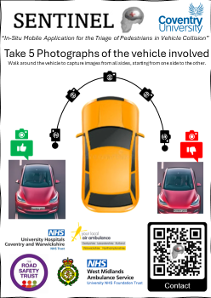
Figure 11: SENTINEL: aide-memoire for WMAS ambulance crews
The IRAS process requested important improvements in the PIS. The following flowchart has been included to help the patient to understand the aim of SENTINEL (Figure 12).
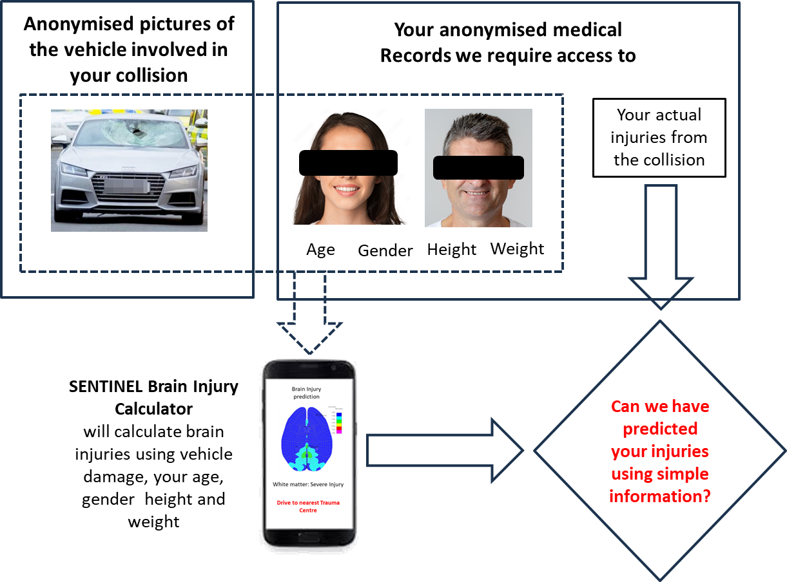
Figure 12: PIS improvement following IRAS meeting

WP5: Management
- Website creation: https://sentinel-rtc.coventry.ac.uk/
- GitHub creation: https://github.com/Sentinel-rtc/SENTINEL-TriageTools
  - Head Injury Criterion (HIC)
  - Severity Index (SI)
  - GAMBIT
  - Head Impact Power (HIP)
  - Wayne State Tolerance Curve (WSPC)
- Presentations:
  - Lime Solicitors (05/12/2024)
  - NHTSA (04/02/2025)
  - Jaguar LandRover (21/04/2025)
  - Police Force:
    - North Yorkshire Police (29/04/2025)
    - Essex Police (29/01/2025)
    - Scottish Police (26/02/2025)
  - Warwick School – STEM presentation (02/05/2025)
- Data Storage: On-going. SENTINEL will be based using a TEAMS site able to store SENTINEL data for a 10-year period.

References
- Addendum 126: Regulation No. 127. Uniform provisions concerning the approval of motor vehicles with regard to their pedestrian safety performance. Entry into force: 17 November 2012 https://unece.org/fileadmin/DAM/trans/main/wp29/wp29regs/2015/R127e.pdf
- Nahum, A.M., Smith, R., Ward, C.C., (1977), Intracranial pressure dynamics during head impact, Proc. 21st Stapp Car Crash Conference, pp.339-366.
- Khanuja T, Unni HN. Intracranial pressure–based validation and analysis of traumatic brain injury using a new three-dimensional finite element human head model. Proceedings of the Institution of Mechanical Engineers, Part H. 2019;234(1):3-15. doi:10.1177/0954411919881526

